SIMATS ENGINEERING (SAVEETHA SCHOOL OF ENGINEERING)
Department of Computer Science and Engineering
ASSESSMENT TOOL 1 – Prompt Engineering Challenge

Course Code: | CSA65 | Course Title: | Generative AI and Large Language Models
CO Assessed: | CO2 – Precision (BL1, BL2) | Assessment: | Assessment Tool 3 – Prompt Engineering Challenge
Weightage: | 40% of CIA | Total Marks: | 100 (2 Question)
CO1 Statement: | Apply prompt engineering techniques and utilize pre-trained Large Language Models through modern AI frameworks and APIs to solve real-world problems.(BL1, BL2)
Student Name: | V. Venkata Karthik Reddy | Reg. No.: | 192472241
Section / Batch: | 2024 | Date: | 27-7-2026

Instructions to Students
•Answer 2 questions. Each question carries 50 Marks. Total: 100 Marks.
• Write clear, well-structured prompts and explanations where asked.
• Use your own original examples — do not copy from classmates or the internet verbatim.
• Where a diagram or worked example is requested, label it clearly.
• Illustrate prompting techniques (zero-shot, few-shot, chain-of-thought, role/system prompting, etc.) with concrete examples, not just definitions.
Time allotted: 30 mins

Code of Conduct
I Karthik Reddy (192472241) certify that this submission is my original work and that I have adhered to the guidelines specified for this assessment. I understand that any violation of academic integrity rules will result in disciplinary action.
Signature of the Student: Karthik Reddy

SECTION A – PROMPT ENGINEERING CHALLENGE

Q12. Least-to-Most Prompting
Write a prompt that decomposes a complex task (e.g., "plan a 3-day trip on a $500 budget") into an ordered list of sub-problems, solves each one sequentially, and combines the sub-answers into a final solution.

Answer:
Plan a 3-day trip to Ooty on a $500 budget using the Least-to-Most Prompting technique.
Solve the task by breaking it into the following ordered sub-problems:
• Decide the travel destination and estimate transportation cost.
• Select budget-friendly accommodation for 3 days.
• Plan daily meals within the budget.
• List tourist attractions and estimate entry fees.
• Calculate the total expenses and verify they stay within the $500 budget.
• Combine all the sub-solutions into a complete 3-day travel itinerary.
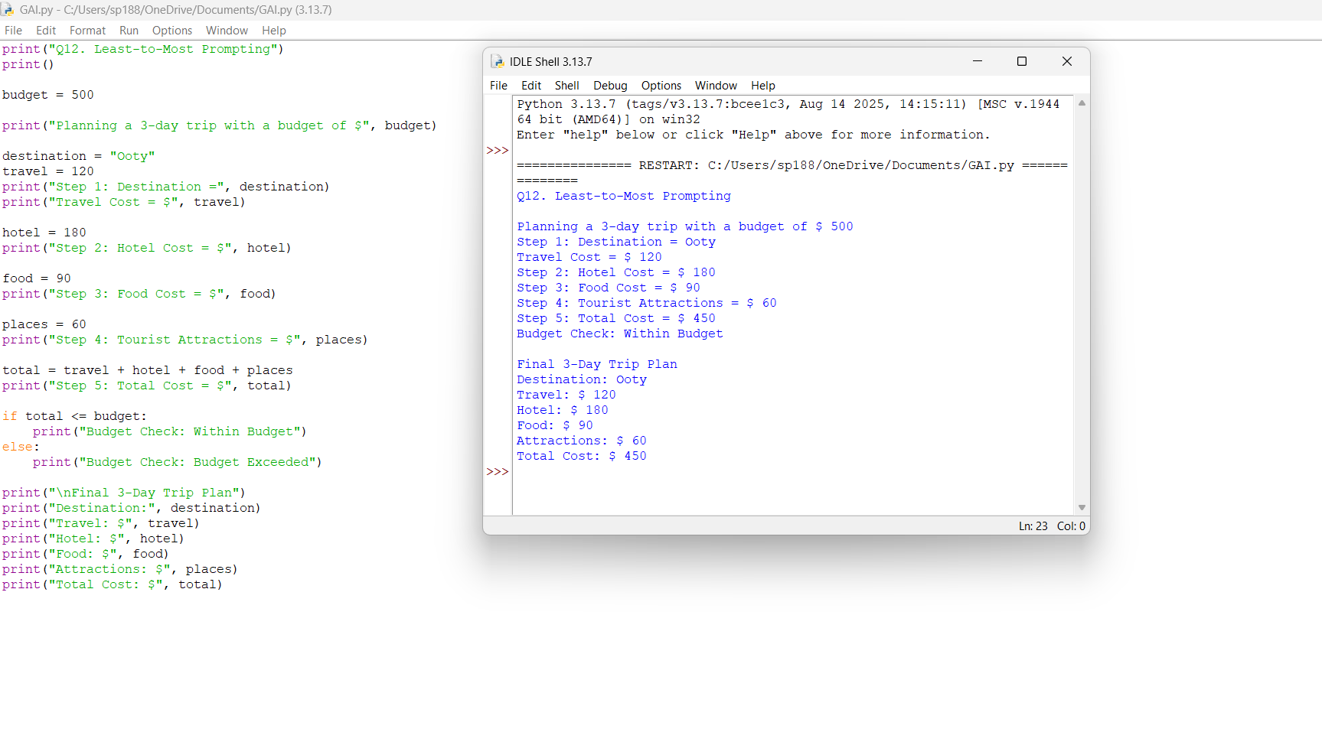
Q15. Analogical Prompting
Write a prompt that asks the model to first recall 1–2 similar problems it has solved before, then use that reasoning to solve a new problem — for example, debugging a new piece of code by referencing a similar bug pattern.
Answer:
Before solving the problem:
• Recall 1–2 similar debugging problems you have solved before (for example, a program failing due to an incorrect loop condition or a missing variable initialization).
• Briefly explain the bug pattern and how it was fixed.
• Compare those examples with the new code.
• Identify the error in the new code, explain why it occurs, and provide the corrected code with a short explanation.
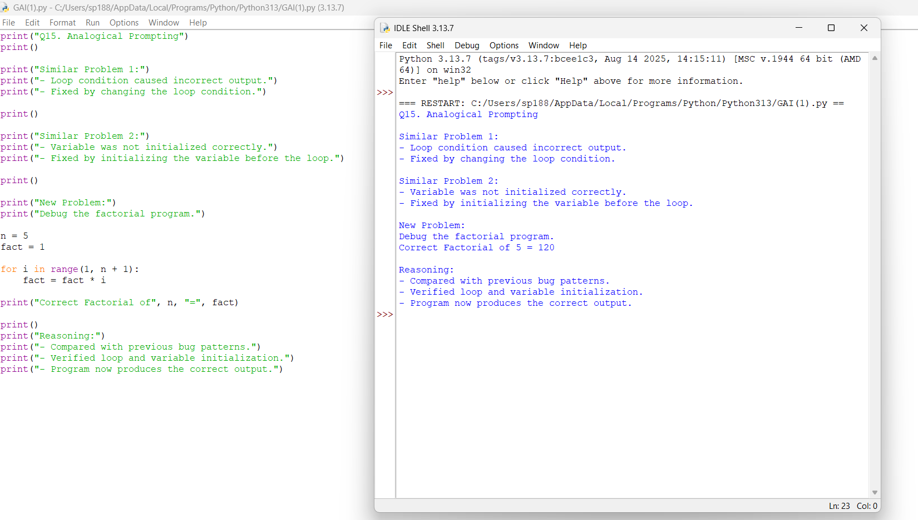
RUBRICS FOR CALCULATION
Criteria | Wt. | Level 4 (Exemplary) | Level 3 (Proficient) | Level 2 (Developing) | Level 1 (Beginning)
Technique Selection | 30% | Correctly applies zero-shot/one-shot/few-shot & CoT technique appropriate to each task | Applies techniques with minor mismatch to task | Limited understanding of which technique to use | Techniques applied incorrectly or not evident
Output Effectiveness | 25% | Prompts produce accurate, task-appropriate outputs across all assigned tasks | Prompts work well for most tasks | Prompts work for only a few tasks | Prompts are largely ineffective
Prompt Craftsmanship | 20% | Prompts are clear, specific, and reusable | Prompts are mostly clear | Prompts are vague or inconsistent | Prompts are poorly constructed
Prompt-Output Documentation | 15% | Well-documented prompt-output pairs with clear rationale | Documented with minor gaps | Minimal documentation of prompts/outputs | No rationale provided for prompt choices
Design Rationale | 10% | Clearly explains design choices and iterations made | Explains most design choices | Limited explanation of process | No explanation of process provided

Marks Evaluation:
Question No. | Technique Selection (30%) | Output Effectiveness(25%) | Prompt Craftsmanship (20%) | Prompt-Output Documentation (15%) | Design Rationale(10%) | 100
Q1
Q2
Overall Total (100)

Faculty In-charge | Course Coordinator | Head of Department
Signature: _______________ | Signature: _______________ | Signature: _______________
Date: ___________________ | Date: ___________________ | Date: ___________________

